**Passing Parameters to Applets**

Parameters are passed to applets in NAME=VALUE pairs in <PARAM> tags between the opening and closing APPLET tags. Inside the applet, you read the values passed through the PARAM tags with the getParameter() method of the java.applet.Applet class.

The applet parameter "Message" is the string to be drawn.

*import java.applet.*;*

*import java.awt.*;*

*public class NetparamApplet extends Applet {*

*private String defaultMessage = "Hello!";*

*public void paint(Graphics g) {*

*String inputFromPage = this.getParameter("Message");*

*if (inputFromPage == null) inputFromPage = defaultMessage;*

*g.drawString(inputFromPage, 50, 25);*

*}*

*}*

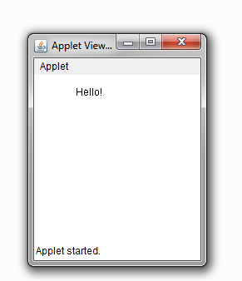

You also need an HTML file that references your applet. The following simple HTML file will do:

*<HTML>*

*<HEAD>*

*<TITLE> Draw String </TITLE>*

*</HEAD>*

*<BODY>*

*This is the applet:<P>*

*<APPLET code="NetparamApplet" width="300" height="50">*

*<PARAM name="Message" value="Howdy, there!">*

*This page will be very boring if your*

*browser doesn't understand Java.*

*</APPLET>*

*</BODY>*

*</HTML>*

Parameterizable applet

You pass getParameter() a string that names the parameter you want. This string should match the name of a PARAM element in the HTML page. getParameter() returns the value of the parameter. All values are passed as strings.

The PARAM element is also straightforward. It occurs between <APPLET> and </APPLET>. It has two attributes of its own, NAME and VALUE. NAME identifies which PARAM this is. VALUE is the string value of the PARAM. Both should be enclosed in double quote marks if they contain white space.